Heaps/Priority Queues
Concept of priority Queues
We get the priority based on rank ,emergency ,percentage etc..
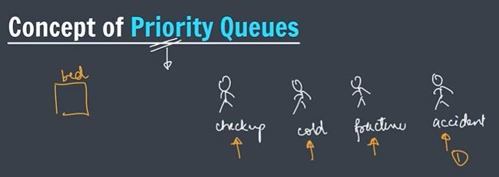
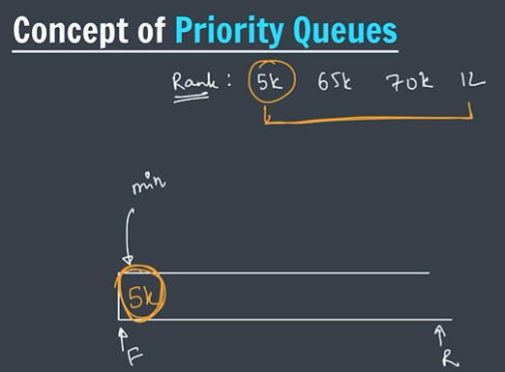
priority Queues in JCF
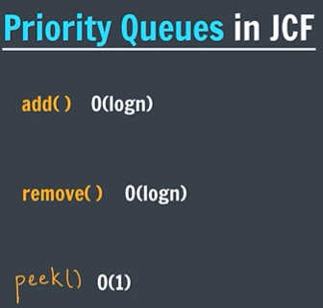
Pq for Objects
Heaps
Here are short notes on Heaps (good for quick revision / exams).

Heaps – Short Notes
1. Definition
A Heap is a complete binary tree that follows a heap property between parent and child nodes.
- It is commonly implemented using an array.
- Used in Priority Queue.

2. Types of Heap
1️⃣ Min Heap
Rule:
Parent ≤ Children
- The smallest element is at the root.
- Removal gives ascending order.
Example:
2
/ \
4 5
/
12
Output:
2 → 4 → 5 → 12

2️⃣ Max Heap
Rule:
Parent ≥ Children
- The largest element is at the root.
- Removal gives descending order.
Example:
12
/ \
5 4
/
2
Output:
12 → 5 → 4 → 2

3. Properties of Heap
- Complete Binary Tree
- Heap Property maintained
- Root contains highest priority element

4. Heap Operations
Operation | Time Complexity
Insert | O(log n)
Delete | O(log n)
Peek (top element) | O(1)
Heapify | O(log n)

5. Array Representation
For index i
Node | Formula
Parent | (i-1)/2
Left Child | 2i + 1
Right Child | 2i + 2

6. Applications of Heap
- Priority Queue
- Heap Sort
- Dijkstra Algorithm
- Top K largest/smallest elements
- Scheduling problems

7. Java Implementation
Min Heap (default):
PriorityQueue<Integer> pq = new PriorityQueue<>();
Max Heap:
PriorityQueue<Integer> pq = new PriorityQueue<>(Collections.reverseOrder());

✅ One-line summary
A Heap is a complete binary tree used to efficiently get the minimum or maximum element.

If you want, I can also give a 1-page DSA interview cheat sheet for Heap (covers Heapify, Heap Sort, PriorityQueue, Top K problems) which is very useful for coding interviews.
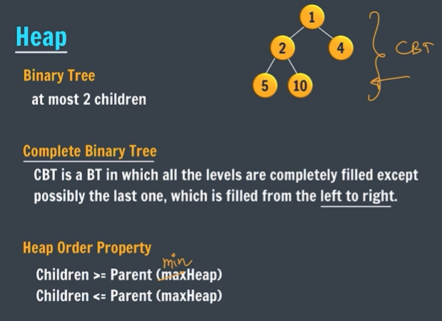
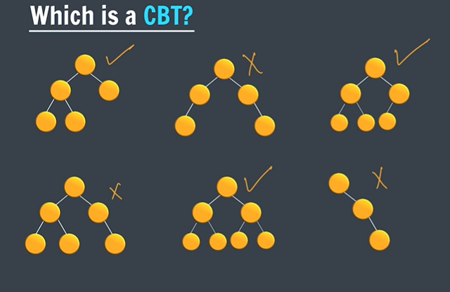
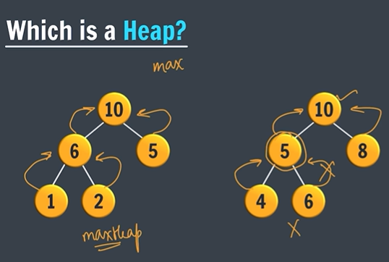
Heap is not implemented as a class nodes
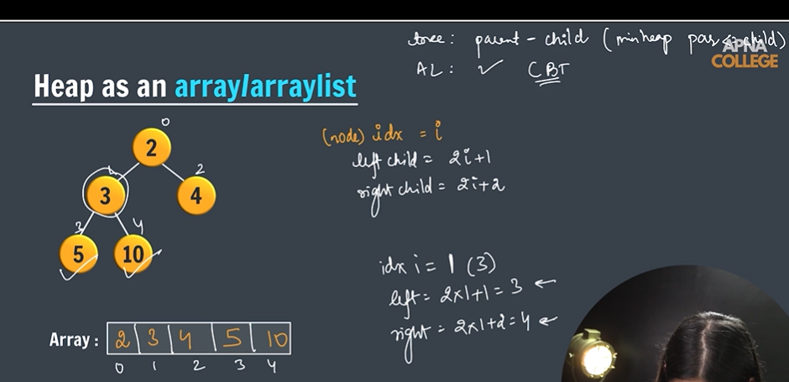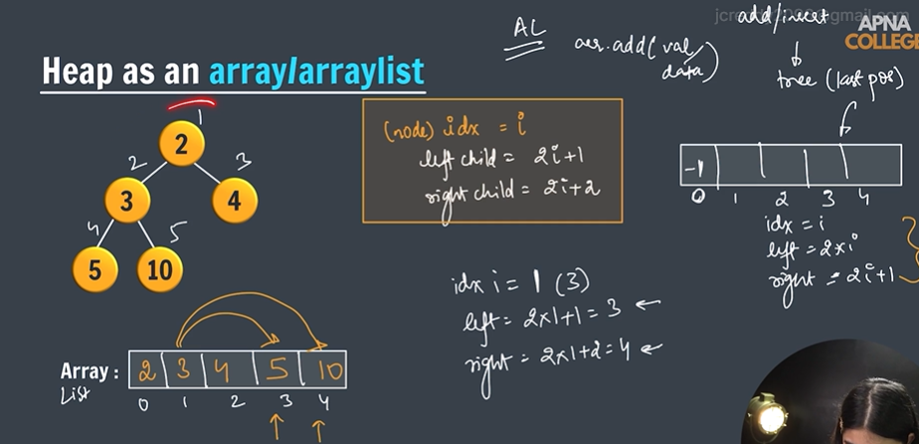
Insert in heap

